**Introduction**

This report contains information about the web application. Detailing information about its the functionalities such as login, contact search and add update and remove contacts. The structure of the database and php/sql code used to interact with the database.

**Web Applications Functionality**

The web applications functionality is to have a secure login setup. The ability to look up contacts by there last name and display them in a user friendly GUI. The ability to add new contacts and update or remove existing ones. Also to check that the users input is valid.

**Database Structure**

The database uses two tables, the first one is called admin it contains login details for users to access the web application. The second table is the Contacts table and it contains the information of users that have been added by administrators.

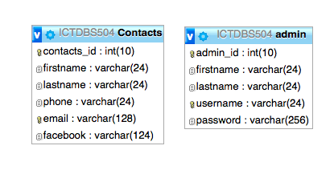

This is the php code that contains the sql code to check if the username and password match and if so create a session and log them in.

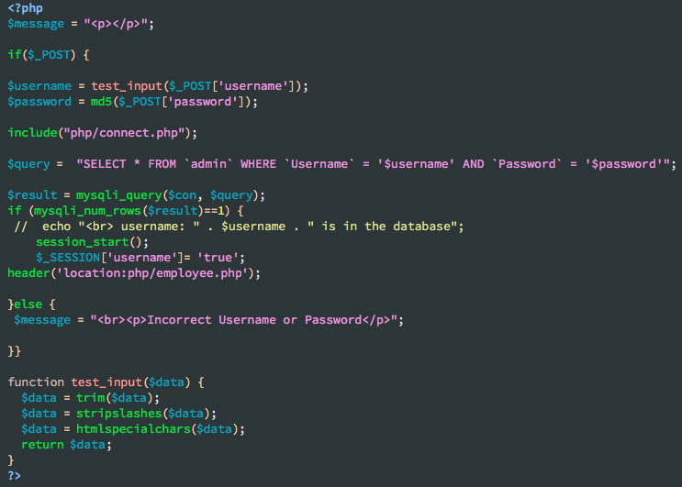

This shows the session checking if user is logged in if not in redirects them to the index page and also shows the logout code.

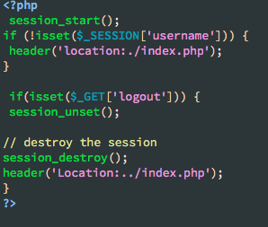

This code displays session again but also a code for deleting contacts from the database.

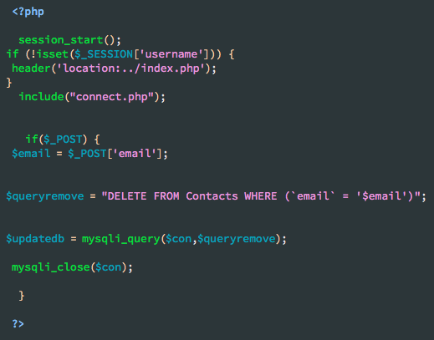

This code though too small to read is the code that searches the database for the last name and then displays it in a table.

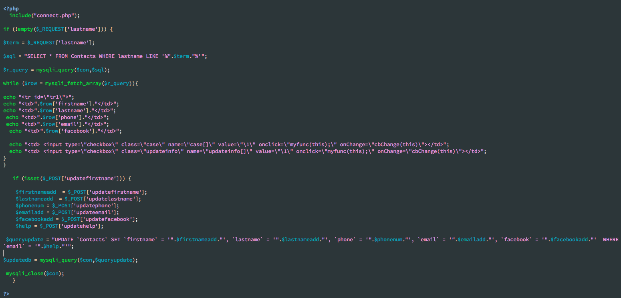

The following code is of adding data into the database and verifying it.

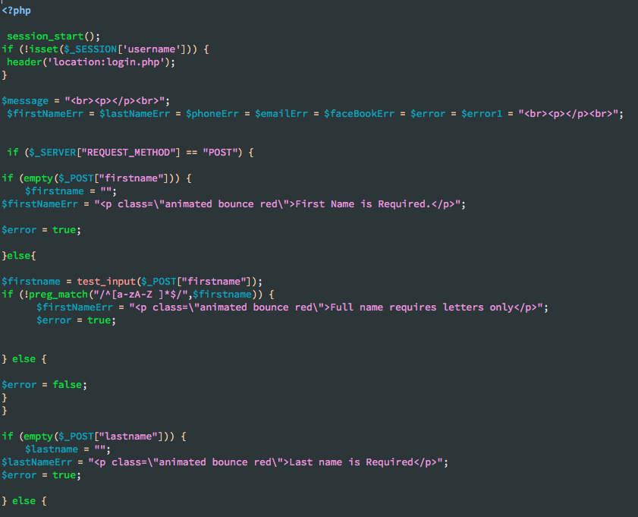

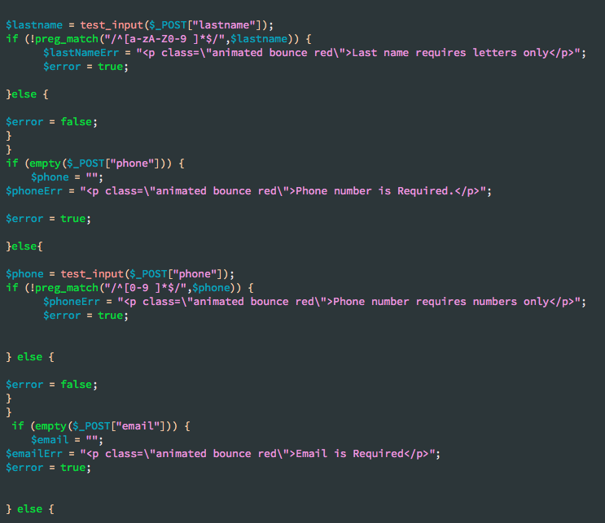

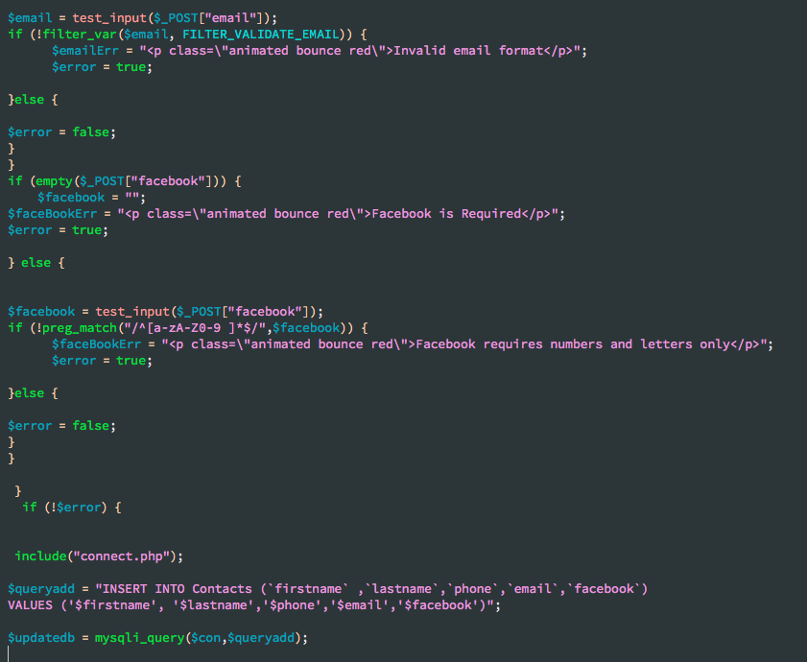

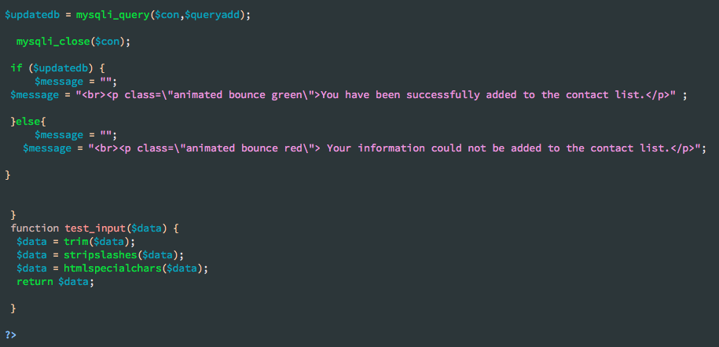

This php code is how the web application connects to the database.

